**INTRODUCTION TO WATER FALL MODEL:**

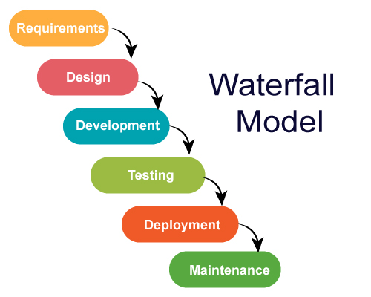

1. First SDLC Model
2. Separate phases
3. Some situations where water fall model is chosen
   1. Well documented, Clear and fixed.
   2. Product design is stable.
   3. Technology is understood
   4. The project is short.
   5. Some expertise must be available to support the product.

**PROBLEM STATEMENT:**

The Baby Toy Company was selling premium toys but the business had been stagnant over the years. They are looking at bringing in new offerings to increase revenue. A survey was conducted on kids and their preference for toys and it was found that attention span/engagement with a new toy lasts only few days for kids and they start demanding a new one within a week. However, the survey also brought out that parents found affording premium toys difficult. Like any business, they saw an opportunity here and decided to launch a new offering of premium toys being available on rent and directed the IT team to make rental option for customers available on their online.

**REQUIREMENTS:**

1. Collect the information.
2. Documentation.
3. Features to be added (Rent option).

**DESIGN:**

1. Hardware requirements.
2. Architecture.
3. Software Requirement.

**IMPLEMENTATION:**

1. Registration.
2. Payment option (Deposition + rent).
3. Rental option: it involves the period of rent, Extension period, due period.
4. Submissions of toy.

**TESTING AND DEPLOYMENT:**

A unit test is a way of testing a unit - the smallest piece of code that can be logically isolated in a system. In most programming languages, that is a function, a subroutine, a method or property Consider this sample code: def divider (a, b) return a/b end Integration testing is the phase in software testing in which individual software modules are combined and tested as a group It occurs after unit testing and before validation testing. Integration testing takes as its input module.

**MAINTENANCE:**

Software maintenance in software engineering is the modification of a software product after delivery to correct faults, to improve performance or other attributes. A common perception of maintenance is that it merely involves fixing defects.

The key software maintenance issues are both managerial and technical. Key management issues are: alignment with customer priorities, staffing, which organization does maintenance, estimating costs. Key technical issues are: limited understanding, impact analysis, testing, maintainability measurement.

An integral part of software is maintenance, which requires an accurate maintenance plan to be constructed during the software development.